# Table content

1. **Introduction**
2. **Wireframes**
3. **Mock-ups**
4. **Testing**

# Introduction

This project is about the weather application created by the group of 5 people. The application works in two ways. First option is the ZIP search and Second option is the city search. At starting of the application the clock with the current time appears and the ZIP search and the City search option are below the clock.

# Wireframes

**Main Page**

# 

**ZIP Search**

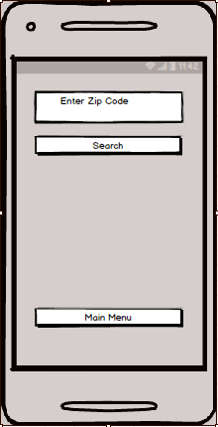

**CITY SEARCH**

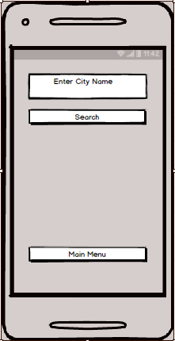

## Mock ups

**Main Page**

At the starting of the Application an Analogic clock and a Digital clock appears with two button option that is ZIP and CITY Search button.

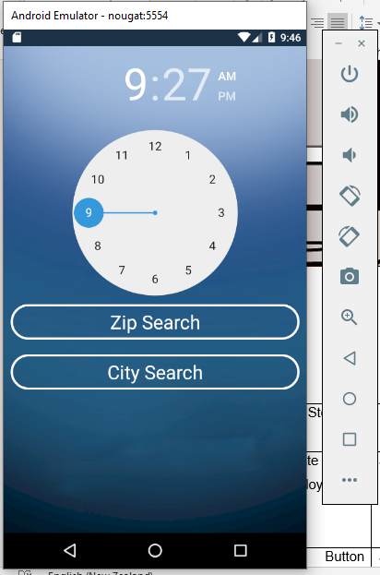

**ZIP Search**

When Clicking on the Zip Search Button another page opens With Two button options.

At the very top there is a text bar Enter the ZIP code of any city and another page will appear with all the details as shown in the below picture:

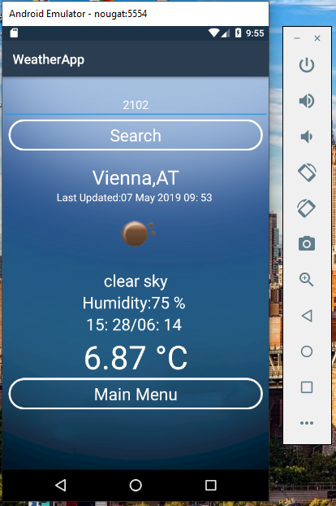

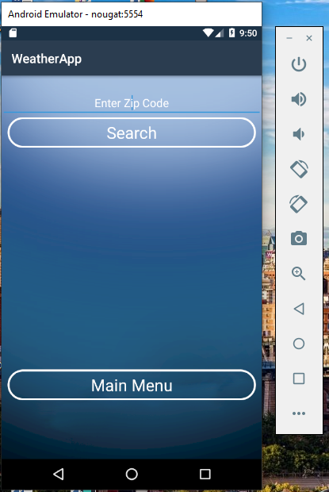

**CITY SEARCH**

**When click on CITY SEARCH button Another page appears with text bar at the very top. Entre the name of any city and another page will appears With the Details as shown in the Picture Below:**

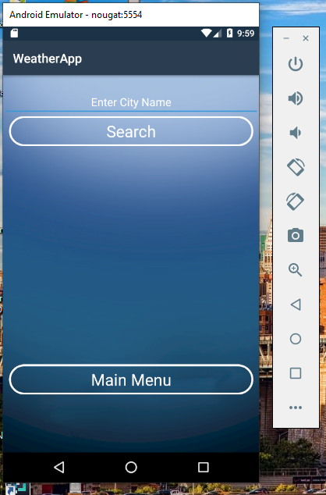

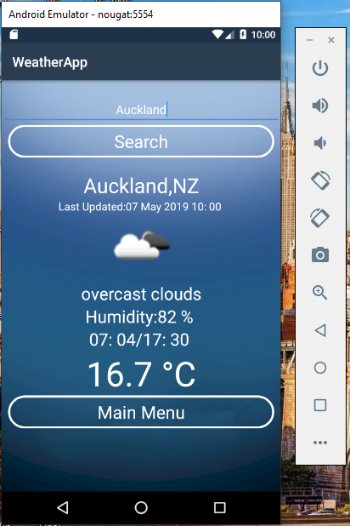

## TESTING: -

|  |  |  |  |  |  |
| --- | --- | --- | --- | --- | --- |
| Step NO | Test Step | Input Data | Expected Result | Actual Result | Test Step Result |
| 1 | Can Change the time of clock | Put any time | Time Should be updated | As Expected | Pass |
| 2 | Click on ZIP Search Button |  | New page opens with New options About ZIP search | As Expected | Pass |
| 3 | Enter the zip code of any city | 2102 | All Details About the weather of that city appears | As Expected | Pass |
| 4 | Click CITY SEARCH Button |  | A new page should appear  On the Screen | As Expected | Pass |
| 5 | Enter the City name | Auckland | All the details about Weather of Auckland city should appears | As Expected | Pass |